SQLite 3 with PHP
Essential Training

Table of Contents
Chapter 02\04: Setting up SID and Exercise files 4
Getting better XAMPP performance on Win7 4
Install SID and CRUD 4
Test SID installation 4
Test CRUD installation 4
Chapter 02\05: Using the command line tools 5
Chapter 03\02: Creating a database with PHP 6
Chapter 03\04: Creating a Table in SQLite 6
Chapter 03\05: Creating a Table in PHP 6
Chapter 03\06: Creating \ Droping Index 6
Chapter 03\07: Indexing ID fields 7
Chapter 04\01: SQLite Data Type 7
Chapter 04\02: CAST 8
Chapter 04\05: Storing large data with BLOB 8
Chapter 04\06: BOOLEAN and CASE WHEN 8
Chapter 04\07: Storing dates and times, DATETIME, JULIANDAY 8
Chapter 05\01: UPDATE table (SET command) 10
Chapter 05\02: SELECT, SUB-SELECT, SUDO JOIN 10
Chapter 05\03: JOIN 11
Chapter 05\04: INSERT 12
Chapter 05\05: DELETE 12
Chapter 06\01: SQLITE3 EXPRESSION 12
Chapter 06\02: BETWEEN 13
Chapter 06\03: LIKE 13
Chapter 06\04: Simple math with arithmetic operators 14
Chapter 06\05: Matching in a List with IN 14
Chapter 06\06: CASE 14
Chapter 06\08: CAST 16
Chapter 07\01: Length Of String 16
Chapter 07\02: Changing case with UPPER and LOWER 17
Chapter 07\03: Reading parts of a string with SUBSTR 17
Chapter 07\04: Changing parts of a string with REPLACE 18
Chapter 07\05: Trimming blank spaces with TRIM, LTRIM, RTRIM 18
Chapter 07\06: ABS – Absolute Values 19
Chapter 07\07: Rounding values with ROUND 19
Chapter 07\10: Getting the version of your SQLite library 20
Chapter 07\11: Creating user-defined functions (UDF) 20
Chapter 08\01: Understanding aggregate functions 21
Chapter 08\02: Counting rows with COUNT 22
Chapter 08\03: Building with the SUM and TOTAL functions 22
Chapter 08\04: MIN and MAX 22
Chapter 08\05: AVG 23
Chapter 09\01: Understanding SQLite support for dates and times 24
Chapter 09\02: Getting readable, sortable dates and times 25
Chapter 09\03: Getting high-resolution dates and times with JULIANDAY 25
Chapter 09\04: Formatting dates and times with STRFTIME 26
Chapter 10\01: Understanding collation 26
Chapter 10\02: Sorting results with ORDER BY 27
Chapter 10\03: Removing duplicate results with DISTINCT 27
Chapter 10\05. Working with primary key indexes 27
Chapter 10\06. How to use INTEGER PRIMARY KEY function 28
Chapter 11\01. Understanding transactions 29
Chapter 11\02. Using transactions in SQLite 29
Chapter 12\02. Creating a simple subselect 29
Chapter 12\03. Searching within a result set 30
Chapter 12\04. Searching within a joined result 31
Chapter 12\05. Creating a view 31
Chapter 12\06. Searching within a joined view 32
Chapter 13\02. Automatically updating a table with a trigger 32
Chapter 13\03. Logging transactions with triggers 33
Chapter 13\04. Improving performance with triggers 34
Chapter 13\05. Preventing unintended updates with triggers 34
Chapter 13\06. Adding automatic time stamps 35
Chapter 14\01. Choosing PHP interface 36
Chapter 14\03. Using the PDO interface 36

Chapter 02\04: Setting up SID and Exercise files

Getting better XAMPP performance on Win7
- Control Panel
- Device manager
- Disk Drives
- Right Click On Disk
- Policies
- Mark 'v' on “Turn off Windows write-cache...”

Install SID and CRUD
- Update sid.php and crud.php files with the default location of:
album.db, world.db, test.db files (copy these files to htdocs dir)
- chmod 777 to album.db, world.db, test.db

Test SID installation
- Open the browser and launch localhost/LOCATION/sid.php
- SID will open
- Choose “test.db”
- Run these code lines:

CREATE TABLE t (a, b);

INSERT INTO t VALUES (1, 2);

SELECT * FROM t;
- Check the results...
- Run: DROP TABLE t;

Test CRUD installation
- Open the browser and launch localhost/LOCATION/crud.php
- Check the you get the required result

Remarks: CRUD is abbreviation of CREATE, READ, UPDATE, DELETE – the basic function of the database

Remarks In SID: - - (MINUS MINUS) remarks the line (will not be execute)

Chapter 02\05: Using the command line tools

$ sqlite3 test.db

SQLite version 3.6.16

Enter ".help" for instructions

Enter SQL statements terminated with a ";"

sqlite> select * from sqlite_master;

table|customer|customer|2|CREATE TABLE customer (

id INTEGER PRIMARY KEY,

name TEXT,

address TEXT,

city TEXT,

state TEXT,

zip TEXT

)

table|item|item|3|CREATE TABLE item (

id INTEGER PRIMARY KEY,

name TEXT,

description TEXT

)

table|sale|sale|4|CREATE TABLE sale (

id INTEGER PRIMARY KEY,

item_id INTEGER,

customer_id INTEGER,

date TEXT,

quantity INTEGER,

price INTEGER

)

.quit

sqlite3 test.db 'select * from customer';
running command directly from the OS

sqlite3 newtest.db < test-sqlite3.sql;
CREATE database from sql backup file

Chapter 03\02: Creating a database with PHP

<?php

define('DATABASE', '/opt/lampp/htdocs/test.db');

try {

$db = new PDO('sqlite:' . DATABASE);

$db->exec('CREATE TABLE IF NOT EXISTS t (a, b, c)');

print 'Table t sucessfully created';

} catch(PDOException $e) {

print $e->getMessage();

}

?>

Chapter 03\04: Creating a Table in SQLite

CREATE TABLE t (a INT, b REAL, c TEXT);

select * from sqlite_master; /* We will see the new table */

Chapter 03\05: Creating a Table in PHP

$db = new PDO('sqlite:' . DATABASE);

$db->exec('CREATE TABLE IF NOT EXISTS t (a INT, b REAL , c TEXT)');

Chapter 03\06: Creating \ Droping Index
The good:
Increasing performance in searches, joins..
The Cost:
Slower inserts and updates and a larger DB files.

CREATE INDEX IF NOT EXISTS co_code ON country(code);
co_code is the index name
country is the table
code is the field
DROP INDEX co_code;

Chapter 03\07: Indexing ID fields

CREATE TABLE t (id INTEGER PRIMARY KEY AUTOINCREMENT,a,b,c);

Remarks: You can drop AUTOINCREMENT (in this case sqlite will reuse old deleted indexes)

Chapter 04\01: SQLite Data Type
Most databases uses static typing: If you insert a number to text column it will be a text (but
in the opposite direction you can't put text in a number field).
In SQLite the column type determine by the value:
Every value stored in a table has a storage class. There are 5 storage classes:
NULL, REAL, INTEGER, TEXT, BLOB.
Each storage class can support more than one storage type.
- NULL – Can be used only for NULL
- INTEGER – Integer value that can be stored as 1,2,3,4,6,8 bytes
- REAL – Floating point number that always stored in 8 byte IEEE floating point num
- TEXT – Is a text string encoding in UTF-8 \ UTF-16
- BLOB – Is a blob of data and stored exactly as provided

Remark:

- SQLite has no boolean type. It can implement with INTEGER with 0,1 values

- SQLite has no date and time type. It will stored as INTEGER, TEXT or REAL (depending on the represented value)
SQLite converts TEXT to INTEGER\REAL only if the conversion is lossless: it must preserve 15 significant digits (in both directions). If lossless conversion is not possible SQLite will use TEXT (even that you declared the column value as INTEGER).
The declaration is only a recommendation to SQLite and it will be use only on a lossless conversion.
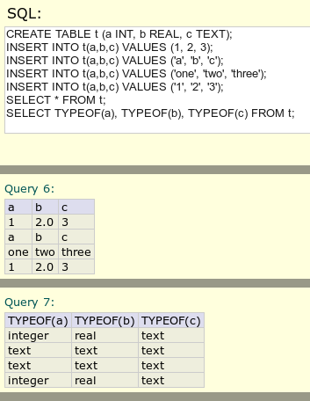

Chapter 04\02: CAST
In order to make monetary calculation you must use INTEGER and works in cents (REAL can make mistakes in monetary calculation)

CREATE TABLE t (product TEXT, price INT);

INSERT INTO t(product,price) VALUES ('table', 223);

SELECT product, CAST(price AS REAL)/100 AS PRICE_IN_DOLLAR from t;
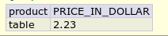

Chapter 04\05: Storing large data with BLOB
‎This chapter demonstrate how to enter a picture to SQLite DB using PHP code.

Chapter 04\06: BOOLEAN and CASE WHEN
SQLite has no Boolean type. However we can implement it by using Integer:
0 = False
1 (or any number <> 0) = True
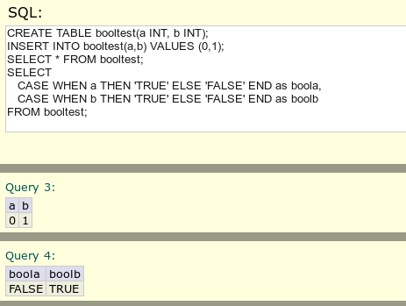

Remarks: “CASE WHEN a THEN 'TRUE' ELSE 'FALSE' END as boola,” means:

Display 'TRUE' if a is True and set the display title to boolb.

Chapter 04\07: Storing dates and times, DATETIME, JULIANDAY
SQLite has no 'Date And Time' type. Date And Time stored as TEXT (but sometime as INTEGER \ REAL – depending on the representation)
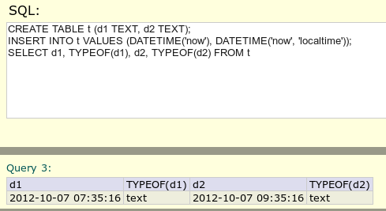

DATETIME('now') – UTC local time

DATETIME('now', 'localtime') – ISRAEL locate time

Notice that date and time stored as TEXT

You can store date and time as REAL using JULIANDAY, and as INTEGER using epoch:
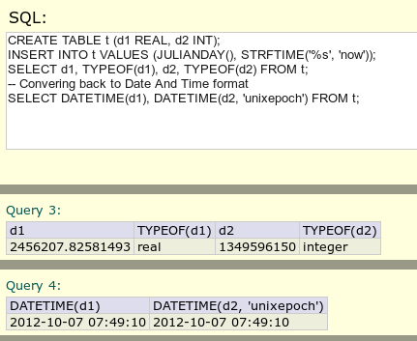

unixepoch doesn't have any special function in SQLite so we use STRFTIME

Usually you will use TEXT to represent Date And Time

Chapter 05\01: UPDATE table (SET command)
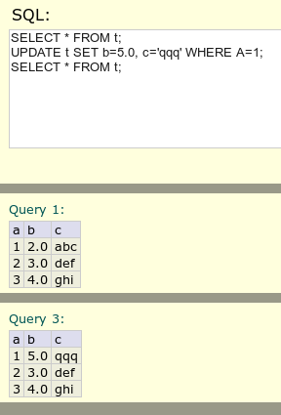

Remark: Don't forget to use WHERE condition in order not to rewrite all your date!

Chapter 05\02: SELECT, SUB-SELECT, SUDO JOIN
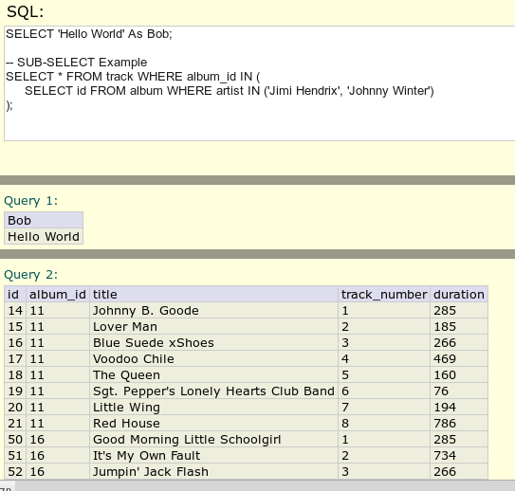

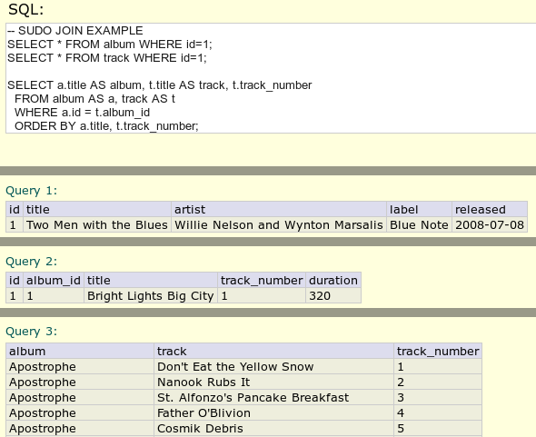

Chapter 05\03: JOIN
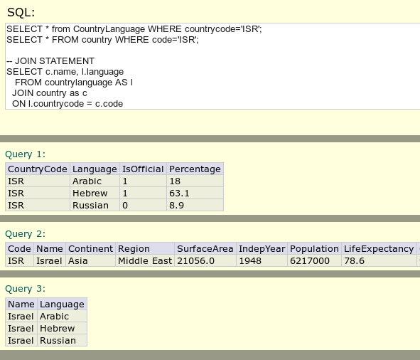

Chapter 05\04: INSERT
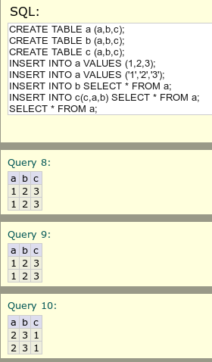

Chapter 05\05: DELETE

DELETE * FROM table_name WHERE colomn_name='some_text';

DELETE * FROM table_name;

Will empty the entire table so don't forget to write the WHERE statement

Chapter 06\01: SQLITE3 EXPRESSION
IS, IS NOT | For comparison
LIKE, GLOB | Glob is like 'like' and it's unique to sqlite3
BETWEEN | X is between y and z (x>=y, x<=z)
IN, NOT IN | Inclusion in list or query result
CASE | Like IF, THAN, ELSE

Chapter 06\02: BETWEEN
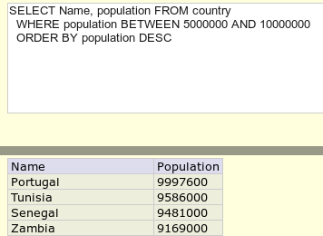

BETWEEN is evaluate only once so it's better than using other expressions

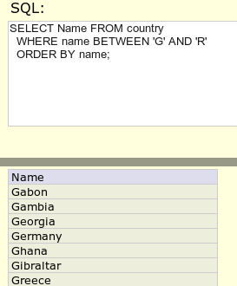

Result will not include R because Rxxx is greater than R. To include R use: BETWEEN 'G' AND 'Rzzz';

Notice that lower case is above upper case

Chapter 06\03: LIKE
SELECT * FROM city WHERE name LIKE 'z%' ORDER BY name

looking for city name STARTING with z

LIKE is case insensitive

SELECT * FROM city WHERE name LIKE '_z%' ORDER BY name

looking for city where second character is z

'_' means any letter

SELECT * FROM city WHERE name GLOB '?z*' ORDER BY name

GLOB works only in SQLite

GLOB is CASE SENSITIVE

'*' For any number of char, '?' For one char

GLOB is more flexible and we work like UNIX (* , ?)

SELECT * FROM city WHERE name GLOB '[zk]*' ORDER BY name

City starts with 'lowercase z' or 'k'

Chapter 06\04: Simple math with arithmetic operators
SELECT 7 * 5; => 35
SELECT 7 / 5; =>1
SELECT 7.0 / 3; => 2.3333
SELECT 7 % 5; => 2

SQLite support all SQL arithmetic operators

Chapter 06\05: Matching in a List with IN
SELECT * FROM city WHERE countrycode IN ('USA', 'GRB');
SELECT * FROM city WHERE countrycode IN
(
SELECT code FROM country WHERE name IN ('United States', 'United Kindom')
)
ORDER BY name

Chapter 06\06: CASE

CASE is the only conditional statement in SQL and is equivalent to: if,then, else

Look carefully at the following example and understand the result values:

In the 3'td example || use for concatenating and it order to understand this complex query you must read it from the inner query to the outer...

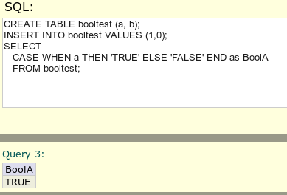

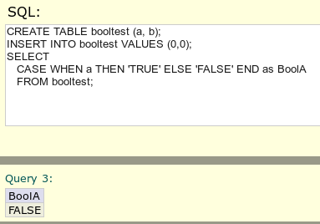

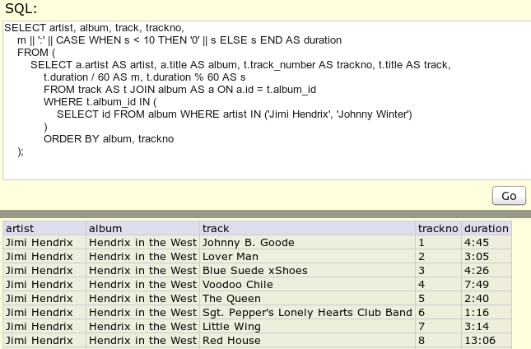

Chapter 06\08: CAST
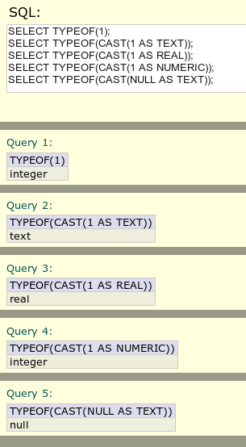

SELECT 7 / 3 => 2

SELECT CAST(7 AS REAL) / 3 => 2.3333

Casing NULL will always be NULL

Chapter 07\01: Length Of String
SELECT name, LENGTH(name) FROM country WHERE LENGTH(name)>10;

Display name, length of name only if the name length > 10
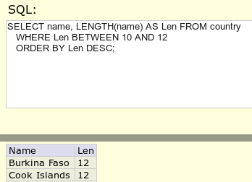

Chapter 07\02: Changing case with UPPER and LOWER
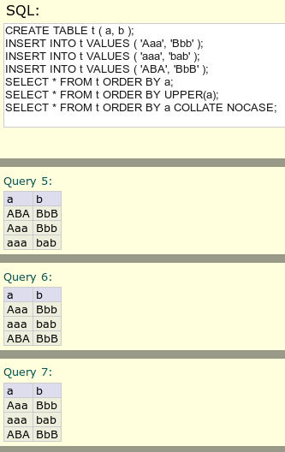

Notice that when sorting strings 'A' comes before 'a' . To solve this problem use UPPER, LOWER or COLLATE NOCASE.

UPPER('axsd') => 'AXSD'

Chapter 07\03: Reading parts of a string with SUBSTR
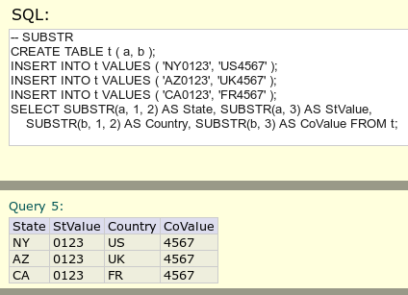

SUBSTR(a, 1, 2) => substring a, starting 2 character from position 1 (in SQLite 1 is the first character)

SUBSTR(a, 3) => substring a, starting from character 3 till the end of the string

Chapter 07\04: Changing parts of a string with REPLACE
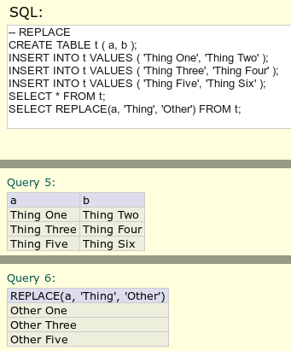

Chapter 07\05: Trimming blank spaces with TRIM, LTRIM, RTRIM
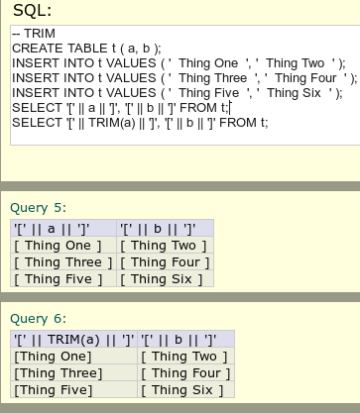

TRIM trim blank spaces from both side of the string
LTRIM trim blank spaces from the left side of the string
RTRIM trim blank spaces from the right side of the string

|| - For concatenating

'[', ']' - For showing the spaces (HTML filter out extra spaces)

Chapter 07\06: ABS – Absolute Values
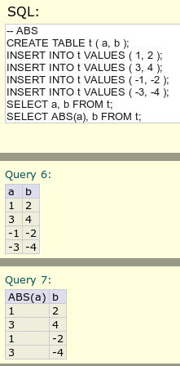

Chapter 07\07: Rounding values with ROUND
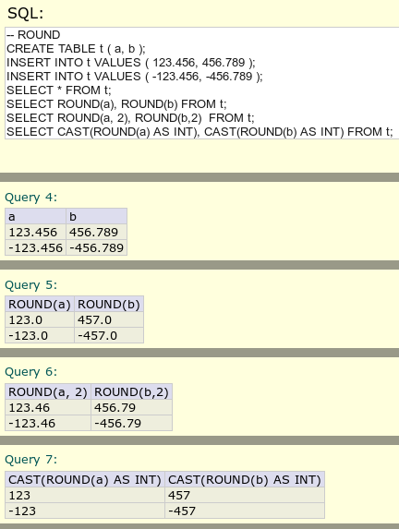

Chapter 07\10: Getting the version of your SQLite library
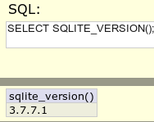

Chapter 07\11: Creating user-defined functions (UDF)
User-defined functions can be write in C or PHP
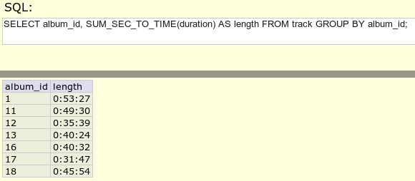

In SID in “function_init” we declare the function:

$dbh->sqliteCreateFunction('TIME_TO_SEC', 'time_to_sec', 1);

The function itself appear in the boby of the PHP code:
// TIME_TO_SEC( time TEXT ) -- 'mm:ss' function time_to_sec( $time )

{

if(is_null($time)) return NULL;

$t = explode(':', $time, 2);

$m = intval($t[0]);

$s = intval($t[1]);

return ( $m * 60 ) + $s;

}

Chapter 08\01: Understanding aggregate functions
Aggregate functions are function that operate on multiple rows at the time.
Example:

SELECT count(*) FROM city;

SELECT AVG(population) FROM city WHERE countrycode = 'USA';

GROUP BY may be used in aggregate functions:

SELECT countrycode, AVG(population) FROM city

GROUP BY countrycode;

In this example all raws are GROUP BY their countrycode and on those raws the AVG function works.

we will get one raw per groups of raws.
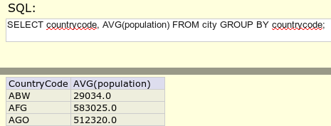

The HAVING clause works like WHERE for aggregation:
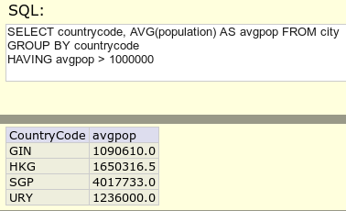

Chapter 08\02: Counting rows with COUNT

SELECT COUNT(*) FROM City;

SELECT District, COUNT(*) FROM City GROUP BY District;

SELECT District, COUNT(*) AS Count FROM City

GROUP BY District

HAVING Count > 10

ORDER BY Count DESC;

Chapter 08\03: Building with the SUM and TOTAL functions

SELECT SUM(Population) FROM Country;

In SQLite SUM will bring INTEGER result if all rows values are integer.

To get floating point number you can use a special SQLite function named TOTAL.

SELECT TOTAL(Population) FROM Country;

SELECT Continent, SUM(Population) AS Pop FROM Country

GROUP BY Continent

ORDER BY Pop DESC;
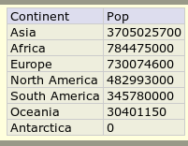

Chapter 08\04: MIN and MAX

SELECT MAX(SurfaceArea) FROM Country;

SELECT Continent, MAX(SurfaceArea) FROM Country GROUP BY Continent;

SELECT c.Name as Country, csa.Continent, csa.MaxSA FROM

(SELECT Continent, MAX(SurfaceArea) as MaxSA FROM Country GROUP BY Continent) AS csa

JOIN Country AS c

ON c.SurfaceArea = csa.MaxSA

ORDER BY MaxSA DESC;

The last query is complication because of the way that GROUP BY works.

There isn't any way to know which name will be choose from the aggregates rows so we need to use

It as Subselect. Than we join another table and choose the right name
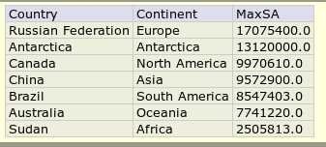

Chapter 08\05: AVG

SELECT AVG(Population) FROM City;

SELECT District, AVG(Population) AS AvgPop FROM City

GROUP BY District

HAVING District != '' AND AvgPop > 1000000

ORDER BY AvgPop DESC;
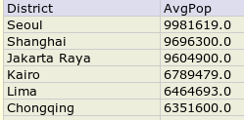

Chapter 09\01: Understanding SQLite support for dates and times
SQLite does not have separate type for date and times
Date and times can be stored in any of three format:
- Text: YYYY-MM-DD HH:MM:SS.SSS
- Real: real number that represent number of days since Julian day
- Integer: Number of days since 1970-01-01
We can convert between these types with built-in functions:
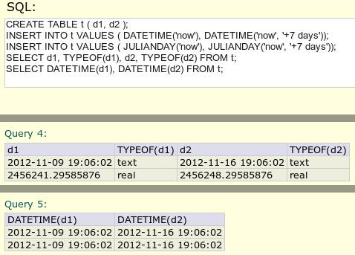

Unix Epoch times are handled a little differently
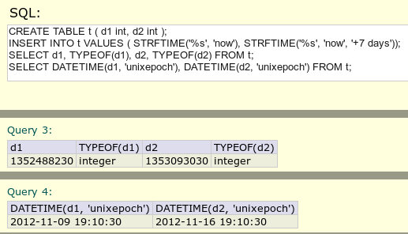

Chapter 09\02: Getting readable, sortable dates and times
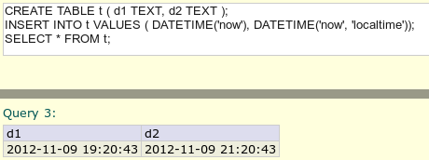

'now', 'now+7' are modifiers. You can use +/- days, months, years, hours, seconds etc...
list of modifiers exist in this link: http://www.sqlite.org/lang_datefunc.html
TIME(field) – will give only the TIME part
DATE(field) – will give only the DATE part
DATETIME(field) – will give both DATE and TIME

Chapter 09\03: Getting high-resolution dates and times with JULIANDAY
JULIANDAY format are high-resolution format that give you access to 1/1000 of seconds.
In the following example you can notice the accurately of JULIANDAY.
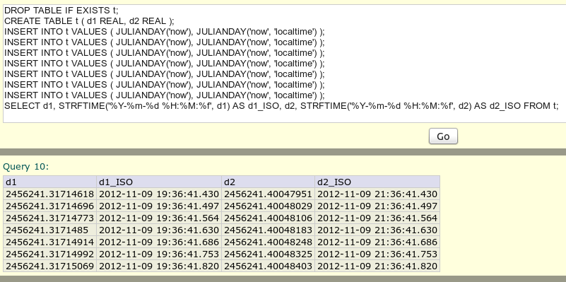

Chapter 09\04: Formatting dates and times with STRFTIME
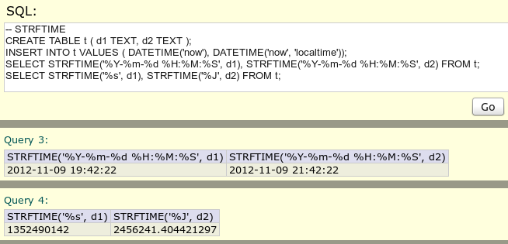

STRFTIME is used to format date and time to other than the standard date and time format.
You can use %Y to get only the year, %H to get the hour:

SELECT STRFTIME('%Y',d1) => 2012

Chapter 10\01: Understanding collation
Collation order is how SQLite compares or sort data
SQLite supports three collation order:
- BINARY - compare values according to the binary values of the field
- NOCASE - works with ASCII. The compare relate to the lowercase field value
- RTRIM – like BINARY but ignore trailing spaces

Collation can be declared in the column definition:

CREATE TABLE t (… colomn_name TYPE COLLATE BINARY, …);

Collation may be specified using COLLATE operator:

SELECT * FROM t COLLATE BINARY;

Chapter 10\02: Sorting results with ORDER BY

SELECT * FROM Country

SELECT * FROM Country ORDER BY Region

SELECT * FROM Country ORDER BY Region, Population

SELECT * FROM Country ORDER BY Region, Population DESC

First it will be sorted by 'Region' than by 'Population'

Chapter 10\03: Removing duplicate results with DISTINCT

SELECT DISTINCT Region FROM Country;

SELECT DISTINCT CountryCode FROM City;

SELECT DISTINCT CountryCode, District FROM City;

Distinct will show only one result and all the result will be alphabetic sorted

Distinct will work on all the combination of CountryCode, Districy so you can get resilt like this:

AFG, Herat

AFG, Kabol

In this example each RAW is distinct from the other

Chapter 10\05. Working with primary key indexes
Only one primary key is allowed in one table
UNIQUE is another index. We can't declared it as primary key so we call it UNIQUE.

CREATE TABLE t (code PRIMARY KEY, value TEXT, ycode UNIQUE );

SELECT * FROM SQLITE_MASTER;

INSERT INTO t VALUES ( 'a', 'thing one', 'one' );

INSERT INTO t VALUES ( 'b', 'thing two', 'two' );

INSERT INTO t VALUES ( 'c', 'thing three', 'three' );

INSERT INTO t VALUES ( 'd', 'thing four', 'four' );

INSERT INTO t VALUES ( 'e', 'thing five', 'five' );

SELECT * FROM t;

We can see in SQLITE_MASTER that there is two indexes

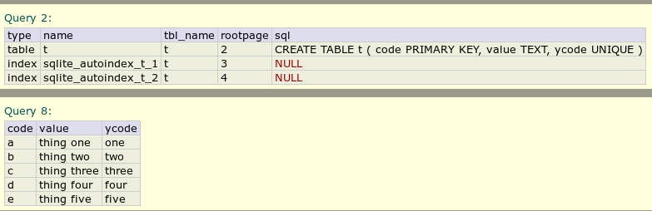

Chapter 10\06. How to use INTEGER PRIMARY KEY function

CREATE TABLE t (id INTEGER PRIMARY KEY AUTOINCREMENT,a,b,c);

INSERT INTO t (a, b, c) VALUES ('a', 'b', 'c');

INSERT INTO t (a, b, c) VALUES ('a', 'b', 'c');

INSERT INTO t (a, b, c) VALUES ('a', 'b', 'c');

INSERT INTO t (a, b, c) VALUES ('a', 'b', 'c');

INSERT INTO t (a, b, c) VALUES ('a', 'b', 'c');

DELETE FROM t WHERE ID = 5;

INSERT INTO t (a, b, c) VALUES ('a', 'b', 'c');

SELECT * FROM t;

SELECT * FROM SQLITE_MASTER;

SELECT * FROM SQLITE_SEQUENCE;
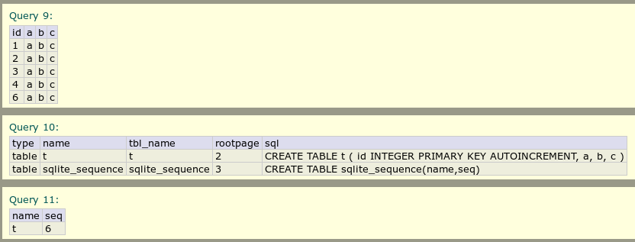

Chapter 11\01. Understanding transactions
Transaction:
- May be used to improve performance
- Is one or more operation that may modify the database
- Transaction written to the database when it's complete successfully
- When it can't be complete successfully a rollback will accour
- The database is locked when the transaction is in progress

Chapter 11\02. Using transactions in SQLite

BEGIN;

INSERT INTO sale (item_id,quantity,price)VALUES (4,12,1995);

UPDATE inventory SET quantity = ( SELECT quantity FROM inventory WHERE id = 4 ) - 12 WHERE id = 4;

COMMIT;

These two operations works as one unit (this is the meaning of transaction):

If, from some reason, one command will fail, the database will remain the same

BEGIN – for starting the transaction, COMMIT for execute all commands as one unit

In this lesson BW demonstrate that 1000 separate inserts action takes 1 second to enter to the database, but as a transaction it will take 40ms (because 1 write to the disk is much faster than 1000 writes)

Chapter 12\02. Creating a simple subselect
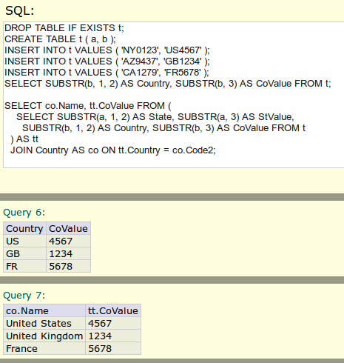

The SUBSELECT evaluate first. It create table name 'tt' with these fields:

State, StValues, Country, CoValue.

Then we join the table country (as 'co') on tt.country = co.code.

In the joined table we select co.Name and tt.CoValue

Chapter 12\03. Searching within a result set
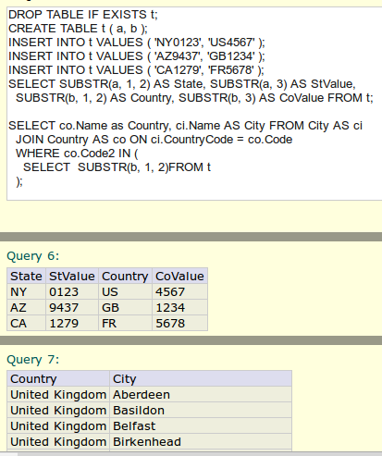

Chapter 12\04. Searching within a joined result
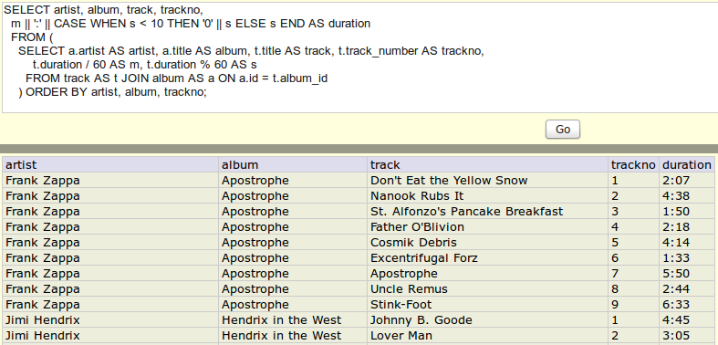

Chapter 12\05. Creating a view
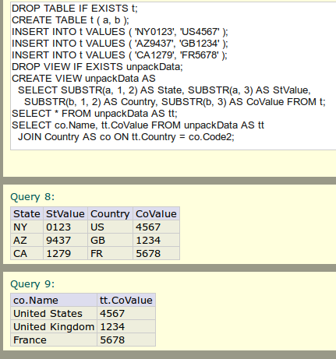

Chapter 12\06. Searching within a joined view
One of the common use of views is to reduce the complexity of the sub-select statements.
The view will bring us the data without the need to run complicated statements
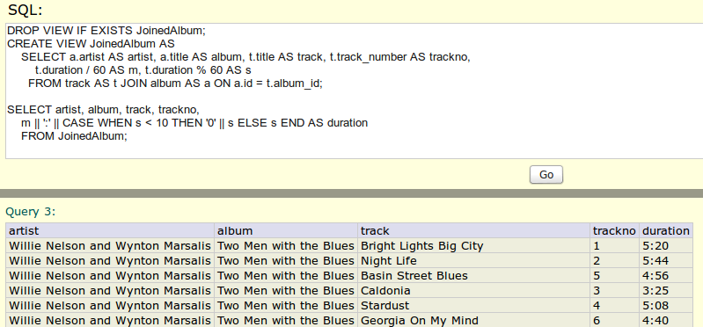

Chapter 13\02. Automatically updating a table with a trigger
Triggers are operation that automatically perform when a specific database event accoure
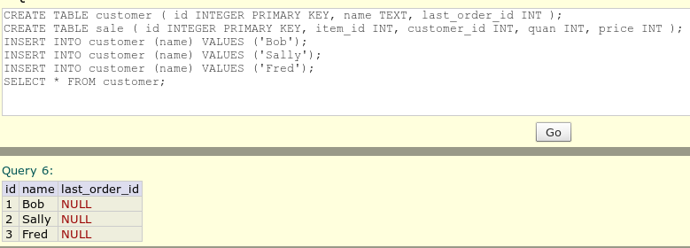
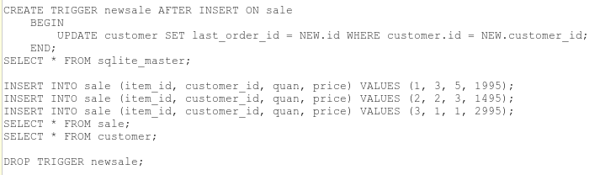
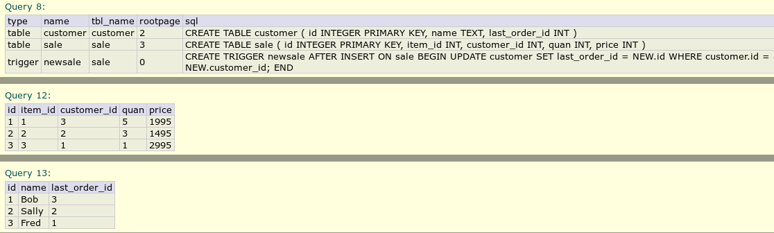

NEW is a virtual table that contain the data from the event that trigger the trigger.

In this example NEW.id contain the id (the primary key value) of the insert to sale event.
Triggers can cause a headache to the developers and it's operation looks like a side effect

Chapter 13\03. Logging transactions with triggers
Triggers good for logging and auditing purpose (update log table with time of the insert).
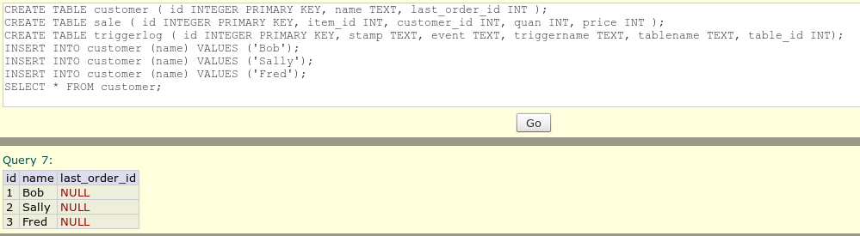
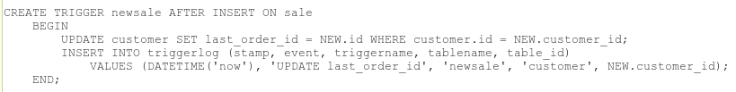
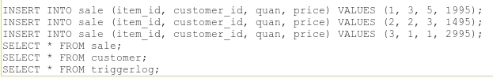

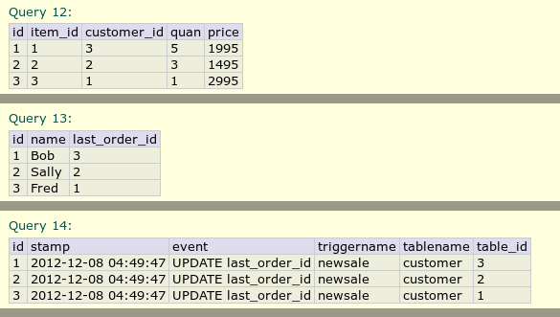

Chapter 13\04. Improving performance with triggers
With triggers we can make reports (as new tables) to users that reduce traffic from busy tables:
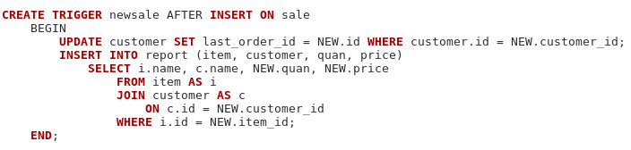

Chapter 13\05. Preventing unintended updates with triggers
Triggers can prevent updating tables that you want to prevent from changing
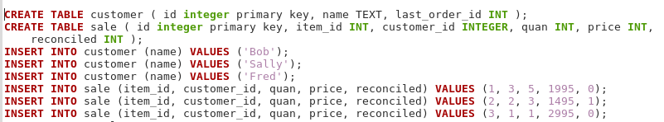
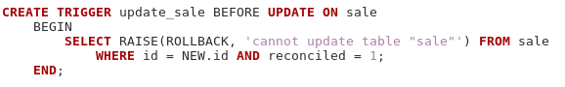

Chapter 13\06. Adding automatic time stamps
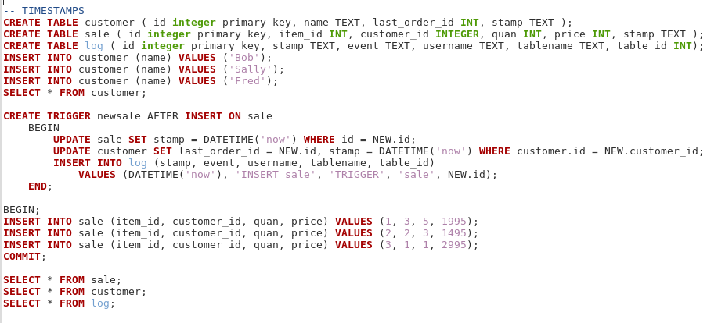
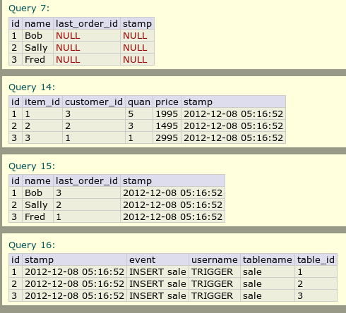

Chapter 14\01. Choosing PHP interface
There are 2 interfaces to use SQLite with PHP:
- PDO:
  - Works across platforms with many type of databases
  - Well maintained
  - Has rich suit of methods
  - Excellent performance
- SQLite3 interface:
  - A native interface to SQLite
  - Poor error handling
PDO is the recommended interface to work with .

Chapter 14\03. Using the PDO interface
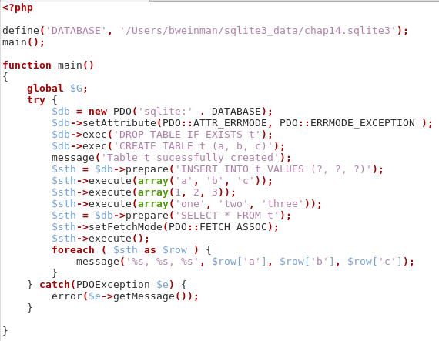

Remarks:

Turn on PDO exceptions for the entire library (this will caught most pdo exceptions

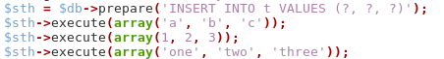

First statements prepare a query that will use over and over...

The following statements will execute queries using $sth (statement handler)

SetTetchMode to be associate array

